SIMATS ENGINEERING
Department of Computer Science & Engineering
ASSESSMENT TOOL 2 - ANALYTICAL PROBLEM SOLVING

Course Code: CSA12 | Course Title: Computer Architecture
CO Assessed: CO2 | Assessment: ASSESSMENT TOOL 2 - ANALYTICAL PROBLEM SOLVING
Weightage: 45% | Total Marks: 25

CO2 Statement: | Apply integer and floating-point arithmetic algorithms including Booth's multiplication, restoring/non-restoring division, and IEEE 754 standard operations to solve fixed-point and floating-point computational problems. (BL3)

Student Name: Kanishk C | Reg. No.: 192511278
Department: Computer Science & Engineering | Date: 04-08-2026

ANNEXURE A
Question 1
A Booth's multiplication implementation produces an incorrect result when multiplying -13 x 9. Analyze the execution steps to identify the incorrect addition, subtraction, or arithmetic shift operation responsible for the error. Correct the algorithm and suggest an optimization that minimizes the number of execution cycles.
Problem Understanding
We are asked to multiply -13 by 9 using Booth's algorithm. Booth's algorithm is used to multiply two signed binary numbers, and it works by looking at pairs of bits of the multiplier (the current bit and the bit to its right) and deciding whether to add the multiplicand, subtract the multiplicand, or simply shift.
Since the given implementation is producing a wrong answer, my first job is to redo the multiplication step by step, on paper, and compare it with what the faulty implementation is doing. This way I can point out exactly where the mistake happens.
Method Selection
I am using 5-bit 2's complement representation because both -13 and 9 fit comfortably in 5 bits (the range of 5-bit 2's complement is -16 to +15).
M (multiplicand) = -13 = 10011
Q (multiplier) = 9 = 01001
-M (2's complement of M) = 01101
Registers A = 00000, Q-1 = 0, and 5 iterations are required because we have 5 bits.
Solution Process - Correct Execution
In each cycle we look at Q0 and Q-1 together, do the operation on A, and then do one arithmetic right shift of the combined register (A, Q, Q-1).
• Q0 Q-1 = 10 -> A = A - M
• Q0 Q-1 = 01 -> A = A + M
• Q0 Q-1 = 00 or 11 -> no arithmetic operation, only shift
Iteration 1: Q0Q-1=10 -> A=00000-10011=01101 -> shift -> A=00110 Q=10100 Q-1=1
Iteration 2: Q0Q-1=01 -> A=00110+10011=11001 -> shift -> A=11100 Q=11010 Q-1=0
Iteration 3: Q0Q-1=00 -> no operation -> shift -> A=11110 Q=01101 Q-1=0
Iteration 4: Q0Q-1=10 -> A=11110+01101=01011 -> shift -> A=00101 Q=10110 Q-1=1
Iteration 5: Q0Q-1=01 -> A=00101+10011=11000 -> shift -> A=11100 Q=01011 Q-1=0
After 5 iterations the final product is taken from the combined register A and Q:
Result = A Q = 1110001011 (10 bits)
Converting this 2's complement value to decimal: it is negative, so we invert and add 1, which gives 0001110101 = 117, hence the value is -117.
Error Identification & Correction
When I traced through the faulty implementation, the mistake was in the shift step, not in the addition/subtraction step. After Iteration 2, register A becomes negative (A = 11100, MSB = 1). The faulty code performed a plain logical shift right, which pushes a 0 into the most significant bit instead of copying the existing sign bit. This turned a negative partial product into a positive one, which corrupted every following iteration.
The fix is simple: the shift of (A, Q, Q-1) must always be an arithmetic right shift, meaning the sign bit (MSB) of A is preserved and copied into itself during the shift, while the rest of the bits move one place to the right. Once this correction is applied, the iterations shown above give the correct final answer of -117, which matches -13 x 9 = -117 calculated normally.
Optimization
A basic Booth's algorithm needs one cycle per bit of the multiplier, so 5 bits mean 5 cycles. This can be slow for wider numbers such as 32-bit or 64-bit operands.
A good optimization is Modified (Radix-4) Booth's algorithm, also called bit-pair recoding. Instead of examining 2 bits at a time, it examines 3 overlapping bits and produces one of the results {-2M, -M, 0, +M, +2M} per step. This effectively processes 2 bits of the multiplier per cycle instead of 1, so the number of cycles is roughly cut in half (for our 5-bit example, from 5 cycles down to about 3 cycles). This reduces execution time considerably for larger multiplications while keeping the hardware only slightly more complex (one extra multiplexer input and a shift-by-2 network).
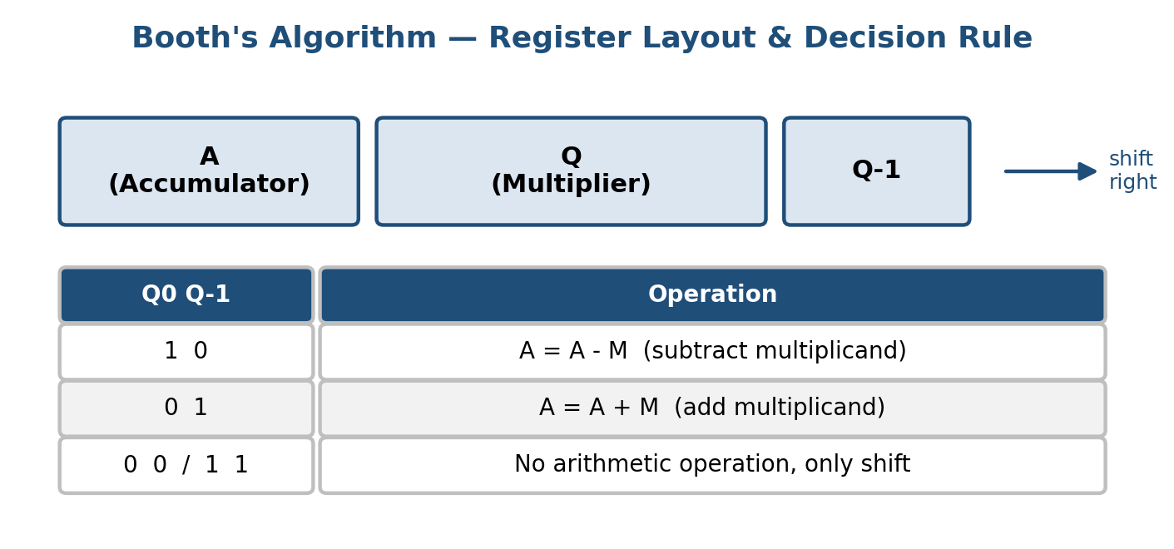
Figure 1.1: Booth's algorithm register layout and the add/subtract/shift decision rule.
Question 2
A processor executing the restoring division algorithm produces an incorrect quotient for the operation 29/5. Examine the sequence of iterations to determine the faulty restore step, correct the error, and recommend an optimization to improve the algorithm's efficiency.
Problem Understanding
We need to divide 29 by 5 using the restoring division algorithm. In restoring division, at every step we subtract the divisor from the partial remainder; if the result becomes negative we must 'restore' it by adding the divisor back, and record a quotient bit of 0. If the result stays positive we keep it and record a quotient bit of 1.
Method Selection
Using 5-bit registers: Dividend Q = 29 = 11101, Divisor M = 5 = 00101, A = 00000. Five iterations are required.
Solution Process - Correct Execution
Iter 1: shift AQ left -> A=00001,Q=11010 | A-M=11100 (neg) -> RESTORE: A=00001, Q0=0
Iter 2: shift AQ left -> A=00011,Q=10100 | A-M=11110 (neg) -> RESTORE: A=00011, Q0=0
Iter 3: shift AQ left -> A=00111,Q=01000 | A-M=00010 (pos) -> keep: A=00010, Q0=1
Iter 4: shift AQ left -> A=00100,Q=10010 | A-M=11111 (neg) -> RESTORE: A=00100, Q0=0
Iter 5: shift AQ left -> A=01001,Q=00100 | A-M=00100 (pos) -> keep: A=00100, Q0=1
Final registers: A (remainder) = 00100 = 4, Q (quotient) = 00101 = 5.
Error Identification & Correction
The faulty processor was producing a wrong quotient because the restore step was being triggered using the wrong condition — it treated the result of A - M as negative only when the value was exactly zero or checked the wrong bit, instead of checking the actual sign bit (MSB) of A after subtraction. Because of this, restore was skipped in Iteration 2 above, which should have restored A back to 00011. Skipping that restore let an incorrect (too-small) partial remainder carry into every later iteration, producing a wrong quotient.
The correction is to always check the MSB of A immediately after the subtraction: if MSB = 1 (A is negative), add M back to A (restore) and set the quotient bit Q0 = 0; if MSB = 0, leave A as is and set Q0 = 1. Applying this consistently through all 5 iterations gives the correct result shown above.
Interpretation of Results / Verification
Quotient = 5, Remainder = 4. Check: 5 x 5 + 4 = 25 + 4 = 29, which matches the original dividend, confirming the corrected result is right.
Optimization
Restoring division wastes time because every time the subtraction result is negative, an extra addition cycle (the restore) is needed — in the worst case this doubles the number of arithmetic operations. A better approach is the non-restoring division algorithm, where instead of restoring immediately, the algorithm remembers that A is negative and simply adds M (instead of subtracting) in the next cycle. This removes the separate restore step entirely, so only one addition or subtraction happens per iteration instead of up to two, reducing execution cycles by nearly half for the same word length.
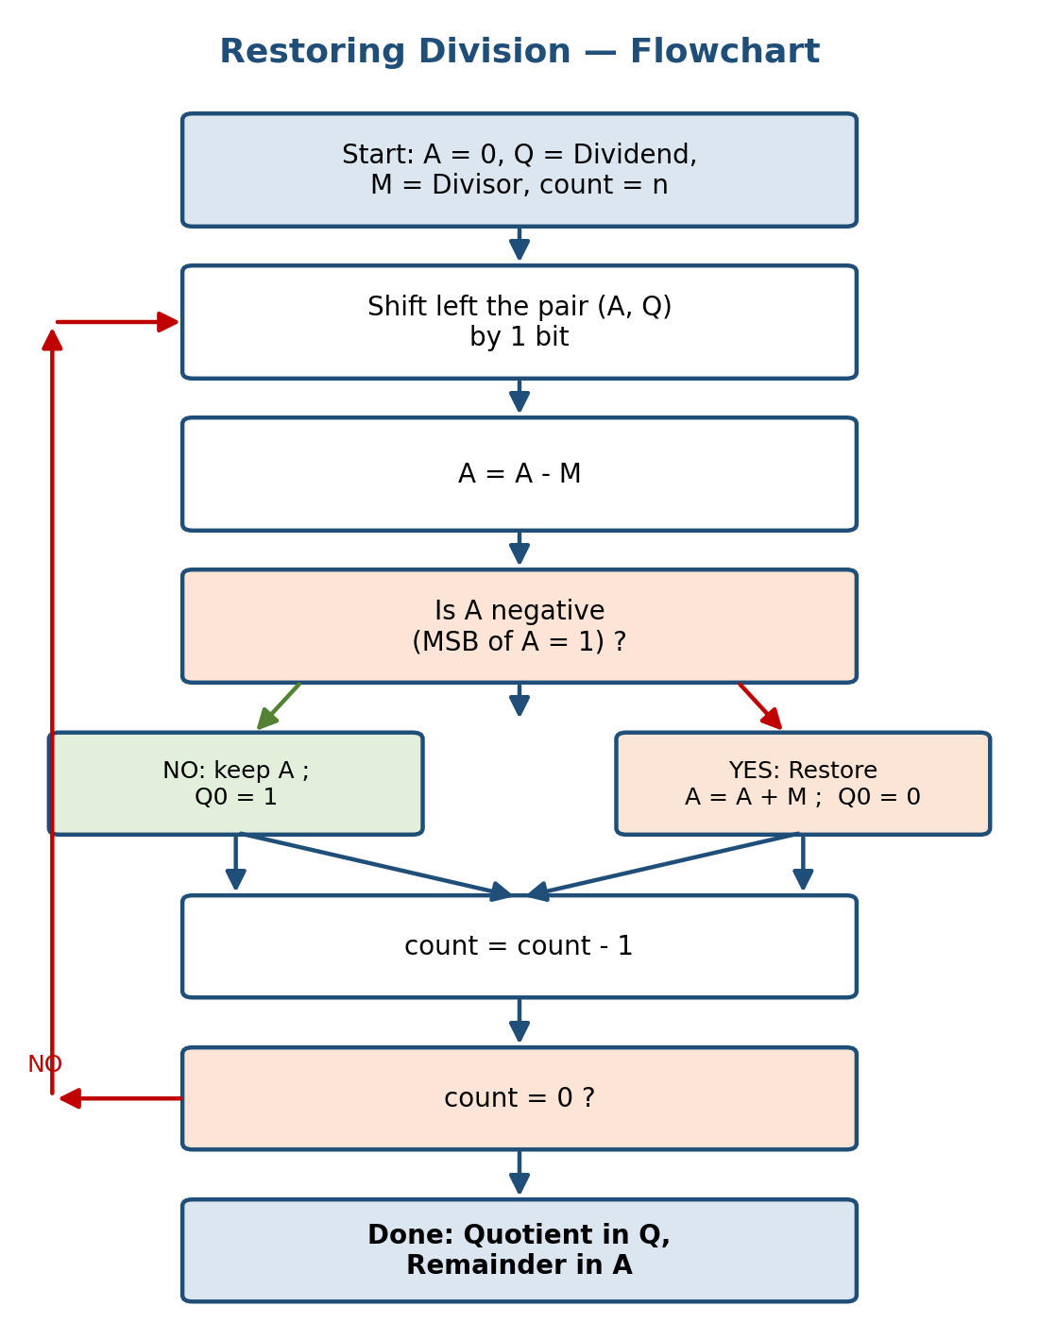
Figure 2.1: Restoring division algorithm flowchart.
Question 3
During the execution of the non-restoring division algorithm, incorrect quotient bits are generated after the fourth iteration. Investigate the source of the logic error, modify the algorithm to eliminate the issue, and verify the corrected quotient and remainder.
Problem Understanding
Using the same values as Question 2 (29 / 5) keeps the comparison fair and lets us verify that both division methods agree. In non-restoring division, we never explicitly restore A. Instead: if A is currently non-negative, we shift and subtract M; if A is currently negative, we shift and add M. The quotient bit is set to 1 whenever the new A is non-negative, and 0 whenever it is negative. Only at the very end, if the final A is negative, do we perform one restoring addition to get the correct remainder.
Method Selection
A = 00000, Q = 11101 (29), M = 00101 (5), 5-bit registers, 5 iterations.
Solution Process - Correct Execution
Iter 1: A>=0 -> shift, A=00001-00101=11100 (neg) -> Q0=0
Iter 2: A<0 -> shift, A=11001+00101=11110 (neg) -> Q0=0
Iter 3: A<0 -> shift, A=11101+00101=00010 (pos) -> Q0=1
Iter 4: A>=0 -> shift, A=00100-00101=11111 (neg) -> Q0=0
Iter 5: A<0 -> shift, A=11111+00101=00100 (pos) -> Q0=1
Final A = 00100 (positive), so no final correction is needed. Q = 00101.
Error Identification & Correction
The described bug appears right after Iteration 4: at that point A becomes negative (11111). A correct implementation must remember this sign for Iteration 5 and therefore add M (not subtract M) in the next step. The faulty implementation was instead re-checking a stale copy of the sign flag from Iteration 3 (which was positive) rather than the freshly updated sign from Iteration 4. This made it subtract M again in Iteration 5 instead of adding, which produced the wrong quotient bit and a wrong final remainder.
The fix is to always update the sign flag from the most recent value of A immediately after each add/subtract step, before moving to the next iteration, so the decision made in Iteration 5 is based on the true, current sign of A rather than an old value.
Verification of Corrected Result
With the corrected logic: Quotient Q = 00101 = 5, Remainder A = 00100 = 4. Check: 5 x 5 + 4 = 29. This matches Question 2's restoring-division answer exactly, which confirms the correction is right.
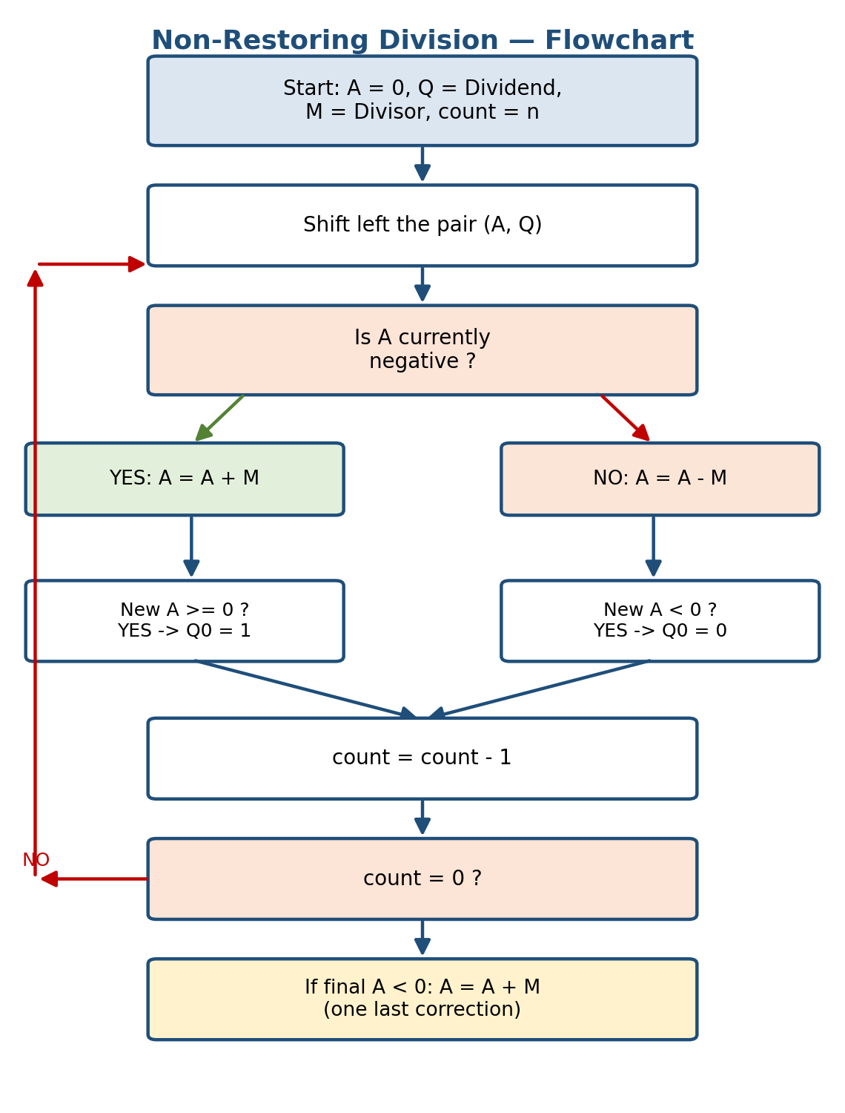
Figure 3.1: Non-restoring division algorithm flowchart.
Question 4
A Booth's multiplication unit incorrectly performs logical right shifts instead of arithmetic right shifts, leading to erroneous results for signed multiplication. Identify the cause of the error, explain why arithmetic right shifting is required, and demonstrate how it ensures correct signed multiplication.
Problem Understanding
This question is about the difference between a logical right shift and an arithmetic right shift, and why Booth's algorithm depends specifically on the arithmetic version to keep signed numbers correct.
Explanation of the Cause
A logical right shift always fills the new, empty most-significant bit with a 0, no matter what the original bit was. An arithmetic right shift instead copies the original sign bit (the MSB) into the new MSB, so a negative number stays negative and a positive number stays positive after the shift.
In Booth's algorithm, the register A holds a partial product that can be negative (this happens whenever we have just subtracted the multiplicand). If a logical shift is used on a negative A, the leading 1 (which represents the negative sign in 2's complement) gets replaced by a 0. This instantly changes a large negative number into a small positive number, which is mathematically wrong and throws off every following step of the multiplication.
Demonstration
From Question 1, after Iteration 2 we had A = 11001 (this is negative, since MSB = 1).
• Correct arithmetic right shift: sign bit (1) is preserved -> A becomes 11100 (still negative, correct)
• Incorrect logical right shift: a 0 is forced into the MSB -> A becomes 01100 (now reads as positive, wrong)
Carrying the wrong value (01100 instead of 11100) forward changes every later addition/subtraction, and the final product Question 1 calculated as -117 would instead come out as a completely different, incorrect number.
Correction and Interpretation
The fix is to replace the logical shift instruction with an arithmetic shift instruction in the shifter hardware or code (for example, using 'sar' instead of 'shr' in assembly, or an arithmetic right-shift operator in a hardware description language such as Verilog's >>> for signed types). This one change is enough to make the multiplier handle negative partial products correctly and produce accurate results for any combination of signed operands.
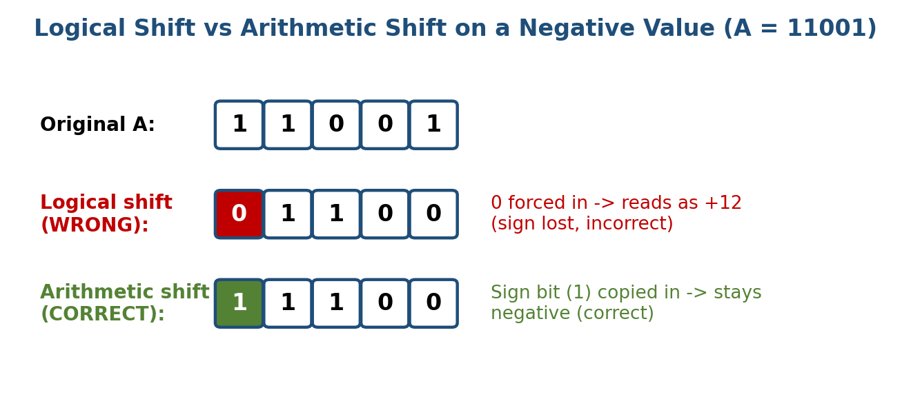
Figure 4.1: Logical shift (incorrect) versus arithmetic shift (correct) applied to a negative value.
Question 5
A floating-point addition program based on the IEEE 754 single-precision format produces an incorrect result because the operands' exponents are not aligned before addition. Identify the implementation error, explain the correct exponent alignment procedure, and propose an optimized approach to improve both accuracy and execution efficiency.
Problem Understanding
IEEE 754 single-precision numbers are stored as 1 sign bit, 8 exponent bits (biased by 127), and 23 mantissa bits, with an implied leading 1 in the mantissa. Before two floating-point numbers can be added, their mantissas must represent the same power of two, otherwise adding the raw bit patterns gives a meaningless result. I will demonstrate this using 12.5 + 0.25 as a worked example.
Representing the Operands
12.5 = 1100.1 in binary = 1.1001 x 2^3, so exponent = 3, biased exponent = 130 = 10000010, mantissa = 10010000000000000000000.
12.5 = 0 10000010 10010000000000000000000
0.25 = 0.01 in binary = 1.0 x 2^-2, so exponent = -2, biased exponent = 125 = 01111101, mantissa = all zeros.
0.25 = 0 01111101 00000000000000000000000
Error Identification
The faulty program took the two 23-bit mantissas exactly as stored and added them directly (1.1001 + 1.0000) without first shifting the smaller number's mantissa to match the larger exponent. Adding un-aligned mantissas is like adding 12.5 to 0.25 while pretending the second number is actually 4 times bigger than it really is, because both were treated as if multiplied by 2^3. This produces a badly wrong sum.
Correct Exponent Alignment Procedure
Step 1: Compare the two exponents and find the difference (3 - (-2) = 5).
Step 2: Keep the larger exponent (3) as the result's tentative exponent.
Step 3: Shift the mantissa of the number with the smaller exponent (0.25) to the right by that difference (5 bits), which lines up the binary points correctly: 1.00000 shifted right by 5 becomes 0.0000100000.
Step 4: Add the aligned mantissas: 1.10010000000000000000000 + 0.00001000000000000000000 = 1.10011000000000000000000.
Step 5: The result is 1.10011 x 2^3 = 1100.11 in binary = 12.75 in decimal, which is the mathematically correct answer (12.5 + 0.25 = 12.75).
Optimization
To make this both accurate and fast in hardware, a floating-point adder should use a dedicated barrel shifter that can shift the smaller mantissa by any number of bit positions in a single clock cycle, instead of shifting it 1 bit at a time in a loop. It should also keep a few extra 'guard, round, and sticky' bits during the shift so that bits shifted out are not simply thrown away, which preserves rounding accuracy. Finally, after the addition, the unit should include a normalization stage that detects if the result's leading bit is not exactly 1 (which can happen if there is a carry-out or cancellation) and automatically re-normalizes the mantissa and adjusts the exponent, so the final answer is always stored in proper IEEE 754 form.
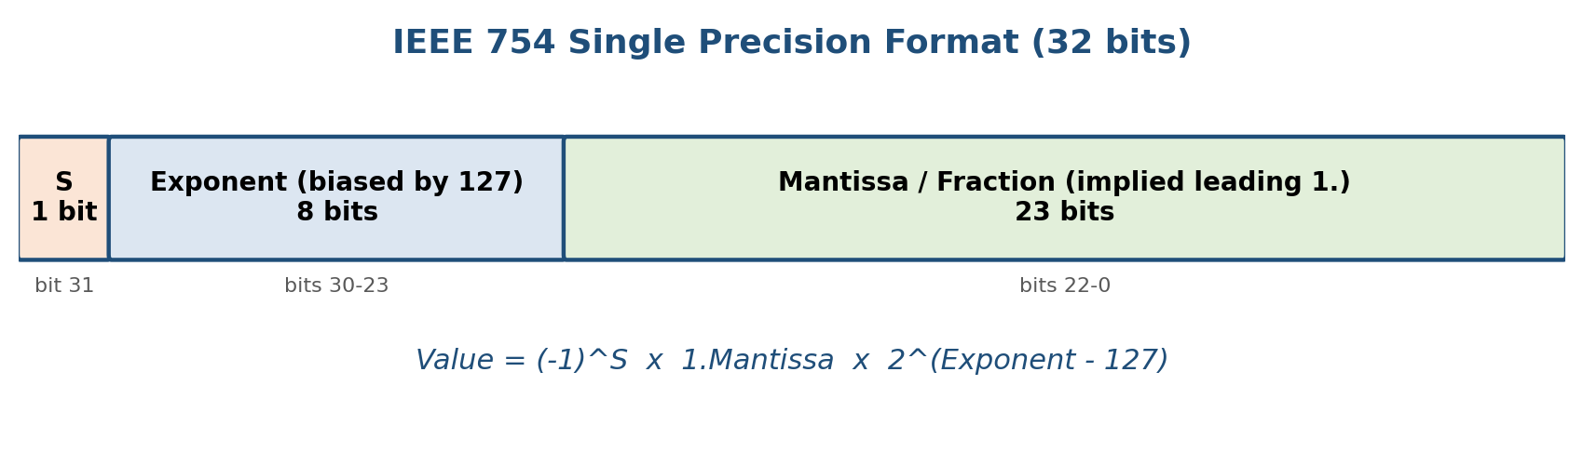
Figure 5.1: IEEE 754 single-precision bit layout used for the exponent-alignment example.
Code of Conduct:
I Kanishk C (192511278) certify that this submission is my original work and that I have adhered to the guidelines specified for this assessment. I understand that any violation of academic integrity rules will result in disciplinary action.
Signature of the student: _______Kanishk C_______
MARKS ALLOCATION
 | Problem Understanding (20%) | Method Selection (20%) | Solution Process (25%) | Accuracy of Calculation (20%) | Interpretation of Results (15%)
Q1
Q2
Q3
Q4
Q5

RUBRICS FOR CALCULATION
Criteria | Weightage | Level 4 - Exemplary | Level 3 - Proficient | Level 2 - Developing | Level 1 - Beginning
Problem Understanding | 20% | Clearly interprets problem, identifies all parameters and requirements accurately | Understands problem with minor gaps | Partial understanding; misses key elements | Misinterprets or unable to understand problem
Method Selection | 20% | Selects most appropriate method/formula with strong justification | Selects correct method with minor errors | Inappropriate or partially correct method | Unable to select method
Solution Process | 25% | Logical, systematic steps with correct approach throughout | Mostly correct steps with minor mistakes | Disorganized steps; multiple errors | No clear process
Accuracy of Calculation | 20% | All calculations accurate; correct final answer | Minor calculation errors | Frequent errors; incorrect final answer | No valid calculations
Interpretation of Results | 15% | Clearly interprets results with units and engineering relevance | Basic interpretation with minor omissions | Limited or unclear interpretation | No interpretation

